
COMSATS University Islamabad
Abbottabad, Pakistan

TrekPal

By

Hashim Ali Khan CIIT/FA22-BSE-/ATD
Ali Usman Tajik CIIT/FA22-BSE-/ATD

Supervisor
Maam Sana Malik

Bachelor of Science in Computer Science (2022-2026)

The candidate confirms that the work submitted is their own and appropriate
credit has been given where reference has been made to the work of others.

COMSATS University, Islamabad Pakistan

TrekPal

A project presented to
COMSATS Institute of Information Technology, Islamabad

In partial fulfillment
of the requirement for the degree of

Bachelor of Science in Computer Science
(2022-2026)

By

Hashim Ali Khan CIIT/FA22-BSE-/ATD
Ali Usman Tajik CIIT/FA22-BSE-/ATD

DECLARATION
We hereby declare that this software, neither whole nor as a part has been copied out from any source. It is further declared that we have developed this software and accompanied report entirely on the basis of our personal efforts. If any part of this project is proved to be copied out from any source or found to be reproduction of some other. We will stand by the consequences. No Portion of the work presented has been submitted of any application for any other degree or qualification of this or any other university or institute of learning.

Hashim Ali Khan Ali Usman Tajik

--------------------------- ---------------------------

CERTIFICATE OF APPROVAL
It is to certify that the final year project of BS (SE) “TrekPal” was developed by
Hashim Ali Khan CIIT/FA22-BSE-/ATD and Ali Usman Tajik CIIT/FA22-BSE-/ATD) under the supervision of “Maam Sana Malik” it is fully adequate, in scope and quality for the degree of Bachelors of Science in Software Engineering

---------------------------------------
Supervisor

---------------------------------------
External Examiner

---------------------------------------
Head of Department
(Department of Computer Science)

EXECUTIVE SUMMARY
In TrekPal is a multi-platform travel management and marketplace system developed to address the inefficiencies of fragmented trip planning. In traditional travel workflows, users often rely on separate services for accommodation, transportation, and itinerary coordination, resulting in duplicated effort, limited pricing transparency, and weak trust in service providers.

TrekPal solves this by unifying travelers, travel agencies, hotels, and platform administrators in a single digital ecosystem.
The system introduces a bid-based trip planning model. Instead of only selecting fixed listings, travelers create structured trip requests with destination, dates, budget, and group size. Travel agencies respond with competitive bids that may include hotel, transport, and package components. This approach increases price competitiveness, supports customization, and improves decision quality for users. The platform also supports direct inventory browsing, booking management, and role-based interactions for operational control.

TrekPal consists of four integrated components: (1) a Flutter traveler application, (2) a React-based agency portal, (3) a React-based hotel portal, and (4) a React-based admin portal, all connected to a centralized backend built with Node.js, Express, and TypeScript. The backend uses PostgreSQL (via Prisma) for relational data management, JWT/Supabase-based authentication, and Socket.IO for real-time features such as chat and live booking/bid updates.
The project follows an Object-Oriented, modular architecture with iterative Agile development. Core modules include authentication and verification, trip request lifecycle, bidding, booking, inventory (hotels/rooms/vehicles), package offers, and administrative approvals. This modular design supports maintainability and future feature expansion.

The outcome is a working end-to-end travel platform that improves transparency, coordination, and service quality in trip planning. TrekPal demonstrates how a unified, role-driven marketplace can modernize travel operations while providing a scalable foundation for future enhancements such as intelligent recommendations, automated offer ranking, stronger analytics, and broader third-party integrations.

ACKNOWLEDGEMENT
All praise is to Almighty Allah who bestowed upon us a minute portion of His boundless knowledge by virtue of which we were able to accomplish this challenging task.

We are greatly indebted to our project supervisor “Maam Sana Malik” Without their personal supervision, advice and valuable guidance, completion of this project would have been doubtful. We are deeply indebted to them for their encouragement and continual help during this work.

And we are also thankful to our parents and family who have been a constant source of encouragement for us and brought us the values of honesty & hard work.

Hashim Ali Khan Ali Usman Tajik

--------------------------- ---------------------------

ABBREVIATIONS
Abbreviation | Defination
API | Application Programming Interface
JWT | JSON Web Token
KYC | Know Your Customer
OTA | Online Travel Agency
DB | Database
SDLC | Software Development Life Cycle
MVP | Minimum Viable Product
REST | Representational State Transfer
UI | User Interface

Table of Contents
1. Introduction 1
1.1 Brief 1
1.2 Relevance to Course Modules 2
1.3 Project Background 3
1.4 Literature Review 3
1.5 Analysis from Literature Review (in the context of your project) 4
1.6 Methodology and Software Lifecycle for This Project 5
2. Problem Defination 6
2.1 Problem Statement 6
2.2 Deliverables and Development Requirements 7
3. Requirement Analysis 9
3.1 Use Case Diagram 9
3.2 Detailed Use Case 10
3.2.1 Traveler Use Cases 10
3.2.2 Travel Agency Usecases 14
3.2.3 Admin Use Cases 18
3.2.4 Hotel Usecase 20
3.3 Functional Requirements 22
3.3.1 Traveler Functional Requirements 22
3.3.2 Travel Agency Functional Requirements 26
3.3.3 Hotel Functional Requirements 29
3.3.4 Admin Functional Requirements 30
3.4 Non-Functional Requirements 32
3.4.1 Usability Requirements 32
3.4.2 Reliability Requirements 32
3.4.3 Performance Requirements 32
4. Design and Architecture 33
4.1 System Architecture 33
4.2 Process Flow Representation 34
4.3 Design Models 35

LIST OF FIGURES

Fig 4.1 Archtecture Diagram 33
Fig 4.2 Process Flow (Traveller) 34
Fig 4.3 Process Flow Agency 34
Fig 4.4 Class Diagram 35
Fig 4.5 Sequence Diagram 36
Fig 4.6 State Transition 37
Fig 4.7 ERD 38

LIST OF TABLES
Table 2.1 Development Requirements 20
Table 3.1 Register / Login 22
Table 3.2 Verification 23
Table 3.3 Hotel Search 23
Table 3.4 Create Trip Request 24
Table 3.5 View and Accept Bids 24
Table 3.6 View Bookings 25
Table 3.7 Join Group Trip 25
Table 3.8 Submit Review 26
Table 3.9 Register Travel Agency 26
Table 3.10 Submit Verification Documents 27
Table 3.11 Manage Hotels, Rooms, and Vehicles 27
Table 3.12 View Trip Requests 28
Table 3.13 View Trip Requests 28
Table 3.14 Manage Bookings 29
Table 3.15 Create Tour Packages 29
Table 3.16 Approve/Reject Agency Registration 30
Table 3.17 Approve/Reject Hotel 30
Table 3.18 Approve/Reject Vehicle 31
Table 3.19 Approve Traveler Verification 31
Table 3.20 View System Analytics 32
Table 3.21 Register Hotel 32
Table 3.22 Manage Rooms and Services 33
Table 3.23 View Booking Activity 33
Table 3.24 Traveler Registration and Login 34
Table 3.25 Traveler Verification 34
Table 3.26 Browse Hotels and Packages 35
Table 3.27 Create Trip Request 35
Table 3.28 View and Accept Bids 36
Table 3.29 View Bookings 36
Table 3.30 Group Trip Participation and Chat 37
Table 3.31 Submit Review 37
Table 3.32 Agency Registration 38
Table 3.33 Agency Verification 38
Table 3.34 Manage Hotels 39
Table 3.35 Manage Rooms & Food Menus 39
Table 3.36 Manage Vehicles 39
Table 3.37 Manage Vehicle Availability 40
Table 3.38 View Trip Requests 40
Table 3.39 Hotel Registration 41
Table 3.40 Manage Rooms and Services 41
Table 3.41 View Booking Activity 42
Table 3.42 Approve/Reject Agency Registration 42
Table 3.43 Approve/Reject Hotels 42
Table 3.44 Approve/Reject Vehicles 43
Table 3.45 Approve Traveler Verification 43
Table 3.46 Content Moderation 44

Introduction
Travel planning in many markets remains fragmented across disconnected service providers, platforms, and communication channels. Travelers often need to separately search for hotels, transportation, and package options, then manually compare prices and coordinate with agencies or vendors. This process is time-consuming, lacks transparency, and frequently leads to inconsistent user experiences. Existing direct-booking platforms improve accessibility, but they generally follow static listing models that provide limited support for personalized negotiation and integrated multi-service trip planning.
TrekPal is developed to address these limitations through a unified, multi-role travel marketplace. The platform connects travelers, travel agencies, hotels, and administrators in a single digital system where trip planning, bidding, booking, and coordination can be managed end-to-end. Its core differentiator is a structured trip-request and bid workflow: travelers define trip requirements (destination, dates, budget, and group size), and agencies respond with competitive offers that can combine accommodation, transport, and related services.
The system is implemented as a multi-platform architecture consisting of:
- A Flutter-based traveler application for trip requests, bid comparison, booking actions, and communication.
- A React-based agency portal for inventory management, package preparation, and bid submission.
- A React-based hotel portal for room/service management and booking visibility.
- A React-based admin portal for verification, moderation, and operational oversight.
- A centralized backend API built with Node.js, Express, and TypeScript, supported by PostgreSQL (via Prisma), role-based authentication, and Socket.IO for real-time updates.

Brief
TrekPal is a full-stack, multi-platform travel marketplace system that digitizes and unifies travel planning by connecting travelers, travel agencies, hotels, and administrators in one ecosystem. The project addresses fragmentation in traditional travel workflows by introducing a structured trip-request and bid-based model, where travelers define requirements and agencies respond with competitive customized offers.

The system outcome is a working end-to-end platform composed of a Flutter traveler application, React-based agency/hotel/admin portals, and a centralized backend developed with Node.js, Express, and TypeScript. The backend integrates PostgreSQL through Prisma, role-based authentication, and Socket.IO for real-time communication and updates.

Development followed an Agile, iterative process with modular Object-Oriented design principles. Core implemented modules include authentication and verification, trip request lifecycle, bidding, bookings, hotel/room and transport inventory, package offers, chat/group coordination, and admin approvals/monitoring.

This report presents the project from problem definition to implementation and evaluation. It explains how TrekPal improves transparency, customization, and operational efficiency in travel planning, while also providing a scalable architectural foundation for future enhancements such as intelligent recommendations, advanced analytics, and third-party service integrations.

Relevance to Course Modules
The TrekPal project strongly reflects the practical application of major BSCS course modules by integrating software engineering, backend systems, frontend development, databases, networking, and system design into one production-style platform.
Software Engineering principles are applied through requirement analysis, modular architecture, SDLC documentation, and iterative Agile development. The project was developed in feature increments across multiple portals and backend modules, with continuous integration of new requirements and fixes.
Object-Oriented Programming (OOP) is reflected in the entity-driven design of system components such as users, agencies, hotels, rooms, vehicles, trip requests, bids, and bookings. Encapsulation, abstraction, and modular class/service structures are used throughout backend and frontend layers for maintainability and reuse.
Database Systems concepts are used in schema design and relational modeling using PostgreSQL with Prisma ORM. The project applies foreign-key relationships, normalization logic, transactional data flows, and role-specific data access patterns for core modules such as bookings, packages, and approvals.
Web Engineering is demonstrated through React-based portals (admin, agency, hotel), component-based UI architecture, state management, API integration, and role-based route/feature control. The portals are designed for operational workflows rather than static pages, making this a strong applied web systems case.
Mobile Application Development is represented by the Flutter traveler app, which provides trip request creation, bid viewing, booking actions, and user-facing travel workflows. It demonstrates cross-platform UI development, provider-based state handling, and backend API consumption in a real use case.
Computer Networks is applied through RESTful API communication, client-server architecture, authentication token flow, and WebSocket-based real-time features using Socket.IO. This includes live chat and event-driven updates for time-sensitive actions like bids and bookings.
Human-Computer Interaction (HCI) concepts are reflected in role-specific interfaces, workflow clarity, and usability-focused separation of concerns. Each portal is tailored to its actor (traveler, agency, hotel, admin), improving task efficiency and reducing interaction complexity..

Project Background
The travel and tourism domain has rapidly shifted toward digital platforms, but many practical workflows remain fragmented. Travelers frequently use separate channels for accommodation, transportation, trip coordination, and agency communication. This causes inefficiency, weak price transparency, and limited control over personalized trip planning. Most existing systems are listing-centric: users browse predefined options and book directly, with minimal structured negotiation between demand and supply sides.
TrekPal was initiated to address this gap by introducing a unified, role-based travel marketplace that combines planning, negotiation, and booking in one system. Instead of forcing travelers to manually coordinate multiple providers, TrekPal enables users to submit structured trip requests and receive competitive, customized bids from agencies. Agencies can combine hotels, transport, and package options into one offer, while the platform ensures verification and operational oversight through administrative controls.

The project evolved from a traditional booking concept into a multi-platform ecosystem consisting of:

- A traveler-facing mobile app for requests, bids, bookings, and communication.
- An agency portal for inventory, offers, bidding, and booking operations.
- A hotel portal for room/service management and booking visibility.
- An admin portal for approvals, moderation, and system supervision.
- A centralized backend API that coordinates all modules with secure authentication, relational data management, and real-time updates.

From a system perspective, TrekPal’s background is rooted in solving three core practical needs:

- Integration: unify hotels, transport, bids, and bookings in one workflow.
- Transparency: enable structured comparison through competitive offers.
- Trust and Control: enforce verification and platform governance through role-based administration.

Literature Review
In Pakistan, digital travel adoption has increased through social media, messaging apps, and online listing platforms, but end-to-end trip planning is still largely fragmented. Travelers commonly use different channels for hotels, transport, and package coordination, often relying on WhatsApp, Facebook pages, informal agents, and separate booking websites. This creates delays, inconsistent pricing, and limited service transparency, especially for domestic tourism routes such as Northern Areas, Murree/Galiyat, Swat, and coastal destinations.

Most currently used solutions in the local market follow a listing and inquiry model rather than a fully integrated transactional workflow. Users browse options, contact providers manually, negotiate separately, and finalize arrangements through calls/messages. Research and market observations in similar developing-platform contexts show that such workflows increase operational friction and reduce comparability between competing offers, particularly when users need bundled services (hotel + transport + itinerary support).

A key issue highlighted in the Pakistan context is trust and verification. Travelers often face uncertainty about provider legitimacy, service quality, and booking reliability. In informal or semi-digital arrangements, listing authenticity, cancellation handling, and post-booking accountability are not always clear. This aligns with broader literature on emerging digital marketplaces, where identity verification, moderation, and provider approval mechanisms significantly improve platform credibility and user confidence.

Another relevant local trend is the growth of mobile-first usage. A large segment of Pakistani users accesses services primarily through smartphones, making app usability, low-friction workflows, and real-time communication essential. Systems that support instant updates, chat-based coordination, and transparent status tracking are better aligned with local user behavior than static, desktop-oriented booking flows.

Analysis from Literature Review (in the context of your project)
The literature and Pakistan-focused market context indicate that existing travel solutions are largely effective for listing visibility but weak in integrated, end-to-end trip coordination. Most workflows remain fragmented across separate providers and communication channels, with travelers manually handling comparison, negotiation, and confirmation. This directly validates TrekPal’s problem framing and design direction.

In relation to the reviewed systems, TrekPal differs in the following important ways:

From static listing to demand-driven planning
Existing platforms are mostly supply-led (users browse what is listed). TrekPal uses a demand-led flow where travelers submit structured trip requests and agencies respond with targeted bids.

From isolated services to bundled offers
Conventional workflows often separate accommodation and transport decisions. TrekPal enables agencies to propose combined offers (hotel + transport + related services), reducing coordination burden for travelers.

From informal negotiation to structured competition
In local practice, price negotiation often occurs privately via calls/messages, making comparison difficult. TrekPal formalizes this into comparable bid submissions, improving transparency and decision quality.

From weak trust signals to controlled verification
Literature emphasizes trust as a major constraint in digital travel marketplaces. TrekPal incorporates role-based verification and admin approval workflows for agencies/hotels/vehicles, improving reliability and platform governance.

From delayed communication to real-time interaction
Local travel coordination relies heavily on messaging, but without structured system state. TrekPal integrates real-time chat and event updates (e.g., bid/booking state changes), aligning with mobile-first usage behavior.

From disconnected operations to platform-level lifecycle management
Existing user journeys often end at booking. TrekPal supports a broader lifecycle: request creation, bidding, offer acceptance, booking tracking, and post-booking interaction..

Methodology and Software Lifecycle for This Project
The development of TrekPal follows an Agile Scrum-based software lifecycle combined with a modular, layered, and object-oriented system design. This approach was selected because the project includes multiple independent yet connected products (traveler app, agency portal, hotel portal, admin portal, and backend services), each with evolving requirements and frequent cross-module integration.
The software lifecycle was executed in iterative phases rather than a strict linear model:
- Requirement Identification and Scope Definition
Core actors (Traveler, Agency, Hotel, Admin) and major workflows (trip requests, bids, bookings, inventory management, approvals, and communication) were finalized from domain analysis.
- System Design and Architecture Planning
A role-based architecture was designed with a centralized backend API and separate frontend clients. Domain entities (User, Agency, Hotel, Room, Vehicle, TripRequest, Bid, Package, Booking, Review, Chat/Group) were modeled and relational dependencies were defined in the database schema.
- Incremental Implementation (Sprint-Based)
Development proceeded feature-by-feature in short iterations. Each sprint targeted a specific vertical slice (e.g., auth, trip requests, bidding, booking flow, admin approvals, room management), enabling early validation and controlled integration.
- Continuous Integration and Refactoring
As modules matured, API contracts, validation rules, and role-guard logic were refined. Cross-portal consistency issues were resolved through iterative fixes and backend-centralized enforcement.
- Testing and Stabilization
Manual and code-level verification was used throughout development to validate role-specific workflows, state transitions, and failure handling (e.g., unauthorized actions, booking constraints, missing profiles, and edge-case payloads).
From a design perspective, TrekPal applies:
- Object-Oriented decomposition for domain modeling and service organization.
- Layered backend structure (routes/controllers/services/repositories/data).
- Component-based frontend architecture for reusable UI and role-focused pages.
- API-first integration between mobile/web clients and backend.
- Event-driven communication for real-time updates where required.
This combined methodology provided two key benefits:
- Flexibility, because features changed and expanded during implementation.
- Maintainability, because modules remained isolated enough for independent fixes and future extension.

Problem Defination

Problem Statement
In Pakistan’s current travel ecosystem, planning and managing a trip is still fragmented across multiple disconnected channels. Travelers often use separate sources for hotels, transport, and agency coordination, including social media pages, messaging apps, informal agents, and listing websites. This creates inefficiency, inconsistent service quality, weak price comparability, and high coordination effort for end users.

Most commonly used digital travel options in this context are listing-driven. Users browse predefined options and then negotiate or confirm details outside the platform. Such systems do not provide a structured mechanism for travelers to express complete trip needs and receive comparable, competitive offers from multiple service providers. As a result, pricing remains static or opaque, customization is limited, and users have reduced control over end-to-end trip decisions.

A second critical issue is trust. In semi-digital and informal arrangements, verification of agencies, hotels, and transport providers is often weak. Travelers may face uncertainty regarding provider authenticity, booking reliability, cancellation handling, and service accountability. At the same time, service providers lack a standardized digital workflow to respond to demand, manage inventory, and coordinate bookings efficiently.

These gaps highlight the need for a centralized, role-driven travel management platform that supports integrated planning, structured bidding, secure booking workflows, and verification controls. The system must:

Unify key travel services (trip requests, offers, hotels, transport, bookings, and communication).
Enable dynamic interaction through a bid-based marketplace instead of only static listings.
Provide transparent, comparable offers aligned with traveler constraints.
Improve trust through approval and moderation workflows.
Support real-time coordination among travelers and service providers.

Deliverables and Development Requirements
The TrekPal project delivers a production-style, multi-platform travel marketplace system composed of client applications, role-specific web portals, and a centralized backend infrastructure. The final deliverables are:
- Traveler Mobile Application (Flutter)
A cross-platform mobile app for travelers that supports account access, profile/KYC flows, trip request creation, bid viewing and acceptance, booking visibility, hotel and transport discovery, group interaction, chat, and review-related actions.
- Agency Web Portal (React)
A web portal for travel agencies to manage business operations, including profile/business workflows, hotel and vehicle inventory handling, package/offer preparation, trip-request response, bid submission, and booking follow-up.
- Hotel Web Portal (React)
A dedicated hotel interface for hotel-side operations such as profile access, room/service management, and booking activity visibility for the hotel account context.
- Admin Web Portal (React)
A governance and control interface for platform administration, including approval/rejection workflows, user/entity management, moderation tasks, and operational monitoring/reporting views.
- Centralized Backend API (Node.js + Express + TypeScript)
A role-aware backend service exposing RESTful endpoints and real-time channels, implementing authentication/authorization, validation, business logic, inventory relations, bidding lifecycle, booking lifecycle, and administrative controls.
- Relational Data Layer (PostgreSQL + Prisma ORM)
Structured schema and persistence for entities such as users, agencies, hotels, rooms, vehicles, trip requests, bids, packages, bookings, chat/group data, and reviews.
- Real-Time Communication Layer (Socket.IO)
Event-driven communication for selected live features such as updates and chat-related coordination between actors.

Table 2.1 Development Requirements

Category | Requirement | Purpose in TrekPal
Frontend (Mobile) | Flutter SDK + Dart | Build and run the traveler mobile application
Frontend (Web) | Node.js + npm + React toolchain | Build and run agency, hotel, and admin portals
Backend Runtime | Node.js + TypeScript + Express | Implement centralized API and business logic
Database | PostgreSQL | Store relational data for users, trips, bids, bookings, inventory, and admin flows
ORM / Data Access | Prisma ORM + migrations | Schema modeling, database access, and migration management
Authentication | Supabase Auth + JWT role tokens | Secure login/session flow and role-based access context
Real-Time Layer | Socket.IO (WebSocket support) | Live chat and event-based updates across actors
API Interface | RESTful endpoints | Standard communication between clients and backend
Security Middleware | Role guards, request validation, CORS | Protect endpoints and enforce authorized access
Media / Files | Configured file/media storage handling | Support document/image upload and retrieval workflows
Configuration | Environment variables (.env) | Manage secrets, API URLs, DB config, auth keys, and CORS origins

Requirement Analysis
This chapter focuses on identifying and understanding the functional and non-functional requirements of the Trekpal System. By thoroughly understanding these requirements, the system can be designed to offer an engaging and user-friendly experience.

Use Case Diagram
The figure 3.1 Use Case Diagram provides a comprehensive overview of the app's functionality, illustrating the various interactions and relationships between its users and the system itself.
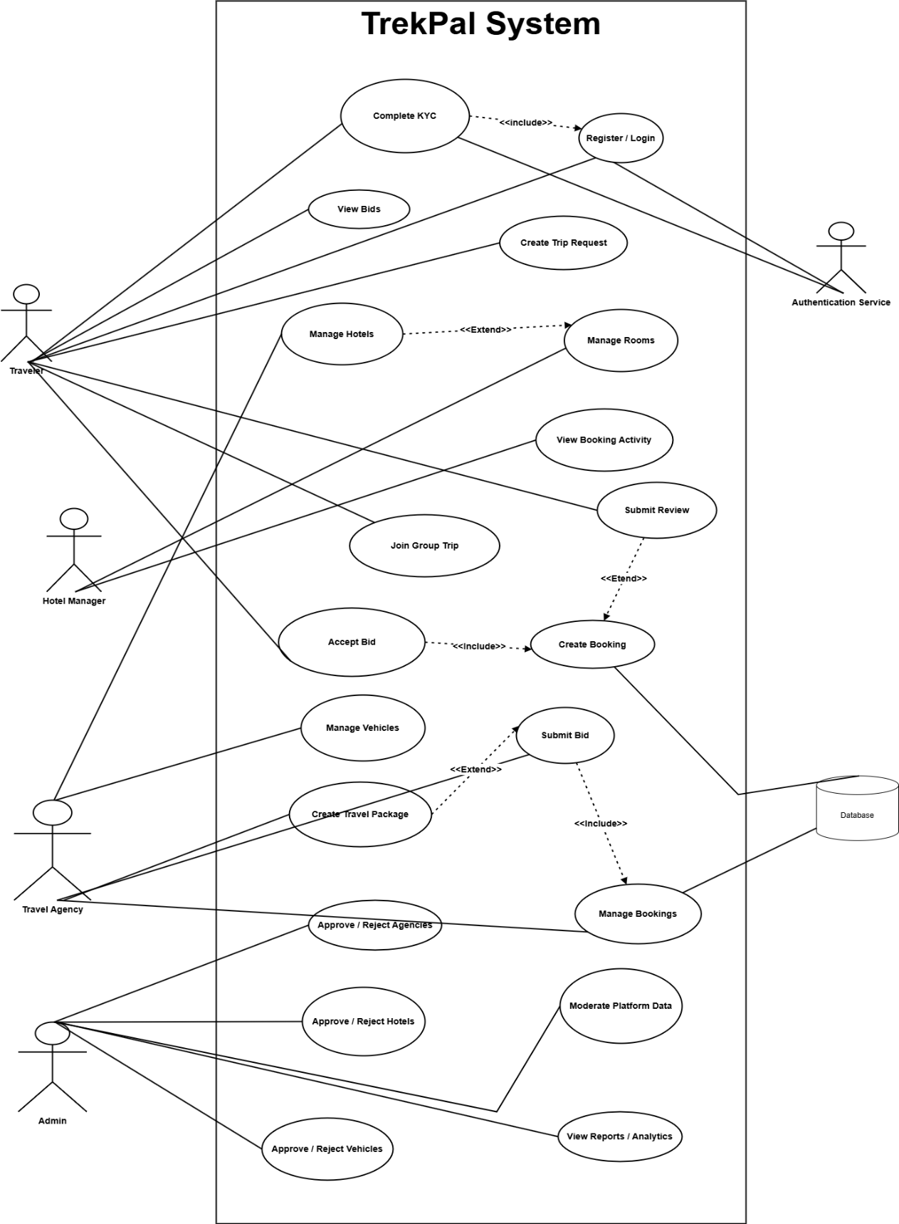
Fig 3.1 Usecase Diagram

Detailed Use Case
A use case description provides a detailed account of how users interact with a system to achieve specific goals, detailing scenarios, steps, and conditions under which each interaction occurs. The following tables shows the functional requirements related to user registration and authentication for the SignSpeak system.

Traveler Use Cases
Traveler use cases are as follows

UC-1: Register / Login

Table 3.1 Register / Login
Field | Description
Use Case ID | UC-TR-01
Use Case Name | Register / Login
Actor | Traveler
Description | The traveler creates an account or logs into the TrekPal mobile application.
Trigger | Traveler selects Sign Up or Login.
Preconditions | None for registration. Existing account required for login.
Postconditions | Traveler account is created or authenticated successfully.
Main Flow | 1. Traveler opens authentication screen. 2. Traveler enters required credentials or registration data. 3. System validates input. 4. System creates account or authenticates traveler. 5. System grants access to the app.
Alternative Flows | AF-1: Invalid input, system displays validation error. AF-2: Email already exists, system asks for a different email. AF-3: Invalid login credentials, system rejects login.

UC-2: Verification
Table 3.2 Verification
Field | Description
Use Case ID | UC-TR-02
Use Case Name | Complete Traveler Verification
Actor | Traveler
Description | The traveler submits verification/KYC information for account approval.
Trigger | Traveler selects verification option from profile or app prompt.
Preconditions | Traveler is registered and logged in.
Postconditions | Verification request is submitted and marked for admin review.
Main Flow | 1. Traveler opens verification form. 2. Traveler enters required personal information and uploads documents. 3. System validates entries. 4. System stores verification request. 5. System marks status as pending.
Alternative Flows | AF-1: Missing required fields, system asks traveler to complete them. AF-2: Invalid file or document format, system rejects upload.

UC-3: Hotel Search
Table 3.3 Hotel Search
Field | Description
Use Case ID | UC-TR-03
Use Case Name | Browse Hotels and Packages
Actor | Traveler
Description | The traveler browses available hotels and travel packages in the platform.
Trigger | Traveler opens hotel or package listing screen.
Preconditions | Traveler is logged in.
Postconditions | Traveler views available listings and details.
Main Flow | 1. Traveler opens listing page. 2. System fetches hotels or packages. 3. Traveler searches or scrolls through listings. 4. Traveler opens a selected item for details.
Alternative Flows | AF-1: No listings available, system shows empty state. AF-2: Data fetch fails, system displays error message.

UC-4: Create Trip Request
Table 3.4 Create Trip Request
Field | Description
Use Case ID | UC-TR-04
Use Case Name | Create Trip Request
Actor | Traveler
Description | The traveler creates a trip request by defining destination, dates, budget, and travel preferences.
Trigger | Traveler selects Create Trip Request.
Preconditions | Traveler is logged in.
Postconditions | A new trip request is created and becomes visible to agencies.
Main Flow | 1. Traveler opens trip request form. 2. Traveler enters trip details. 3. System validates the information. 4. System saves the request. 5. System publishes the request for agency bidding.
Alternative Flows | AF-1: Missing required fields, system shows validation errors. AF-2: Submission fails, system asks traveler to try again.

UC-5: View and Accept Bids
Table 3.5 View and Accept Bids
Field | Description
Use Case ID | UC-TR-05
Use Case Name | View and Accept Bids
Actor | Traveler
Description | The traveler reviews bids submitted by agencies and accepts a suitable offer.
Trigger | Traveler opens a trip request with received bids.
Preconditions | Traveler has an active trip request and at least one bid exists.
Postconditions | Selected bid is accepted and booking flow proceeds.
Main Flow | 1. Traveler opens trip request details. 2. System displays submitted bids. 3. Traveler compares offers. 4. Traveler selects one bid. 5. System records acceptance and updates bid status.
Alternative Flows | AF-1: No bids available, system shows waiting state. AF-2: Accepted bid becomes unavailable, system shows failure notice.

UC-6: View Bookings
Table 3.6 View Bookings
Field | Description
Use Case ID | UC-TR-06
Use Case Name | View Bookings
Actor | Traveler
Description | The traveler checks confirmed or previous bookings in the app.
Trigger | Traveler opens the bookings section.
Preconditions | Traveler is logged in.
Postconditions | Traveler sees current or past booking records.
Main Flow | 1. Traveler opens bookings page. 2. System retrieves booking list. 3. Traveler views booking summary. 4. Traveler may open a booking for more details.
Alternative Flows | AF-1: No bookings exist, system shows empty state. AF-2: Booking data fails to load, system displays error.

UC-7: Join Group Trip
Table 3.7 Join Group Trip
Field | Description
Use Case ID | UC-TR-07
Use Case Name | Join Group Trip
Actor | Traveler
Description | The traveler joins a group trip and communicates with other members.
Trigger | Traveler enters a group trip
Preconditions | Traveler is part of an eligible trip/group.
Postconditions | Traveler joins the group space and can exchange messages.
Main Flow | 1. Traveler opens group trip section. 2. System verifies group membership. 3. System opens group details. 4. Traveler sends and receives messages.
Alternative Flows | AF-1: Traveler is not authorized for the group, system denies access. AF-2: Chat service unavailable, system shows error state.

UC-8: Submit Review
Table 3.8 Submit Review
Field | Description
Use Case ID | UC-TR-08
Use Case Name | Submit Review
Actor | Traveler
Description | The traveler submits a review for a completed booking, hotel, or related travel experience.
Trigger | Traveler selects Write Review.
Preconditions | Traveler has a completed eligible trip or booking.
Postconditions | Review is saved and linked to the related entity.
Main Flow | 1. Traveler opens review form. 2. Traveler enters rating and comments. 3. System validates review data. 4. System stores the review. 5. Review becomes visible in the platform.
Alternative Flows | AF-1: Traveler is not eligible to review, system blocks submission. AF-2: Missing rating or content, system shows validation error.

Travel Agency Usecases
Travel Agency use cases are as follows

UC-AG-01: Register Travel Agency
Table 3.9 Register Travel Agency
Field | Description
Use Case ID | UC-AG-01
Use Case Name | Register Travel Agency
Actor | Travel Agency
Description | The agency creates a new business account in the agency portal.
Trigger | Agency selects Register.
Preconditions | None
Postconditions | Agency account is created.
Main Flow | 1. Agency opens registration form. 2. Agency enters business and account details. 3. System validates the data. 4. System creates the agency account. 5. Agency can proceed to verification steps.
Alternative Flows | AF-1: Invalid or incomplete data, system shows errors. AF-2: Email already exists, system requests a different email.

UC-AG-02: Submit Verification Documents
Table 3.10 Submit Verification Documents
Field | Description
Use Case ID | UC-AG-02
Use Case Name | Submit Verification Documents
Actor | Travel Agency
Description | The agency uploads required business verification documents for approval.
Trigger | Agency opens verification submission page.
Preconditions | Agency account exists and agency is logged in.
Postconditions | Verification request is submitted for admin review.
Main Flow | 1. Agency opens verification form. 2. Agency uploads documents and enters required details. 3. System validates submission. 4. System stores the request. 5. Status becomes pending approval.
Alternative Flows | AF-1: Invalid file format or missing documents, system rejects submission. AF-2: Upload failure, system asks agency to retry.

UC-AG-03: Manage Hotels, Rooms, and Vehicles
Table 3.11 Manage Hotels, Rooms, and Vehicles
Field | Description
Use Case ID | UC-AG-03
Use Case Name | Manage Hotels, Rooms, and Vehicles
Actor | Travel Agency
Description | The agency creates and updates inventory related to hotels, rooms, menus, and vehicles.
Trigger | Agency opens inventory management section.
Preconditions | Agency is logged in and authorized.
Postconditions | Inventory records are added, updated, or removed.
Main Flow | 1. Agency selects inventory type. 2. Agency adds or edits details. 3. System validates entries. 4. System stores inventory changes. 5. Updated inventory appears in agency records.
Alternative Flows | AF-1: Required fields missing, system shows validation errors. AF-2: Unauthorized or unapproved inventory action, system blocks operation.

UC-AG-04: View Trip Requests
Table 3.12 View Trip Requests
Field | Description
Use Case ID | UC-AG-04
Use Case Name | View Trip Requests
Actor | Travel Agency
Description | The agency views traveler trip requests available for bidding.
Trigger | Agency opens trip request marketplace.
Preconditions | Agency is logged in and has portal access.
Postconditions | Agency can inspect requests and choose relevant ones.
Main Flow | 1. Agency opens trip requests page. 2. System retrieves open requests. 3. Agency reviews request details. 4. Agency selects a request to respond to.
Alternative Flows | AF-1: No active trip requests, system shows empty state. AF-2: Data retrieval fails, system displays error.

UC-AG-05: View Trip Requests

Table 3.13 View Trip Requests
Field | Description
Use Case ID | UC-AG-04
Use Case Name | View Trip Requests
Actor | Travel Agency
Description | The agency views traveler trip requests available for bidding.
Trigger | Agency opens trip request marketplace.
Preconditions | Agency is logged in and has portal access.
Postconditions | Agency can inspect requests and choose relevant ones.
Main Flow | 1. Agency opens trip requests page. 2. System retrieves open requests. 3. Agency reviews request details. 4. Agency selects a request to respond to.
Alternative Flows | AF-1: No active trip requests, system shows empty state. AF-2: Data retrieval fails, system displays error.

UC-AG-06: Manage Bookings

Table 3.14 Manage Bookings
Field | Description
Use Case ID | UC-AG-06
Use Case Name | Manage Bookings
Actor | Travel Agency
Description | The agency views and manages accepted bookings related to submitted offers.
Trigger | Agency opens bookings section.
Preconditions | Agency is logged in and has booking records.
Postconditions | Booking details or statuses are updated.
Main Flow | 1. Agency opens bookings page. 2. System lists agency-related bookings. 3. Agency reviews booking details. 4. Agency updates status or follows up operationally. 5. System saves changes.
Alternative Flows | AF-1: No bookings available, system shows empty state. AF-2: Update request fails, system displays error.

UC-AG-07: Create Tour Packages

Table 3.15 Create Tour Packages
Field | Description
Use Case ID | UC-AG-07
Use Case Name | Create Tour Packages
Actor | Travel Agency
Description | The agency creates tour packages that can be listed for travelers.
Trigger | Agency selects Create Package.
Preconditions | Agency is logged in.
Postconditions | New package is created and published in the system.
Main Flow | 1. Agency opens package creation form. 2. Agency enters package information. 3. System validates the details. 4. System saves the package. 5. Package becomes available for traveler viewing.
Alternative Flows | AF-1: Missing or invalid package details, system shows validation errors. AF-2: Save operation fails, system asks agency to retry.

Admin Use Cases
Admin use cases are as follows

UC-ADM-01: Approve/Reject Agency Registration

Table 3.16 Approve/Reject Agency Registration
Field | Description
Use Case ID | UC-ADM-01
Use Case Name | Approve / Reject Travel Agency Registration
Actor | Admin
Description | The admin reviews agency registration requests and decides whether to approve or reject them.
Trigger | Admin opens pending agency approvals.
Preconditions | Admin is authenticated and agency requests exist.
Postconditions | Agency status is updated to approved or rejected.
Main Flow | 1. Admin opens agency approval list. 2. Admin reviews submitted details and documents. 3. Admin selects approve or reject. 4. System updates agency status. 5. Agency is informed of the result.
Alternative Flows | AF-1: Agency record incomplete, admin delays decision. AF-2: Update operation fails, system shows error.
Use Case ID | UC-ADM-01

UC-ADM-02: Approve/Reject Hotel

Table 3.17 Approve/Reject Hotel
Field | Description
Use Case ID | UC-ADM-02
Use Case Name | Approve / Reject Hotels
Actor | Admin
Description | The admin reviews hotel records submitted to the platform and approves or rejects them.
Trigger | Admin opens hotel review section.
Preconditions | Admin is authenticated and hotel submissions exist.
Postconditions | Hotel status is updated.
Main Flow | 1. Admin views hotel submissions. 2. Admin reviews hotel information. 3. Admin approves or rejects the hotel. 4. System saves decision.
Alternative Flows | AF-1: Submission data incomplete, admin postpones decision. AF-2: Save fails, system displays error.

UC-ADM-03: Approve/Reject Vehicle
Table 3.18 Approve/Reject Vehicle
Field | Description
Use Case ID | UC-ADM-03
Use Case Name | Approve / Reject Vehicles
Actor | Admin
Description | The admin reviews vehicle records submitted by agencies and decides approval status.
Trigger | Admin opens vehicle review section.
Preconditions | Admin is authenticated and vehicle submissions exist.
Postconditions | Vehicle status is updated.

UC-ADM-04: Approve Traveler Verification
Table 3.19 Approve Traveler Verification
Field | Description
Use Case ID | UC-ADM-04
Use Case Name | Approve Traveler Verification
Actor | Admin
Description | The admin reviews traveler KYC submissions and approves or rejects verification.
Trigger | Admin opens traveler verification requests.
Preconditions | Admin is authenticated and traveler verification records exist.
Postconditions | Traveler verification status is updated.
Main Flow | 1. Admin opens verification list. 2. Admin reviews submitted documents. 3. Admin approves or rejects the verification. 4. System saves the updated status.
Alternative Flows | AF-1: Documents unclear or incomplete, admin rejects or delays review. AF-2: Update request fails, system displays error.

UC-ADM-05: View System Analytics
Table 3.20 View System Analytics
Field | Description
Use Case ID | UC-ADM-05
Use Case Name | View System Analytics
Actor | Admin
Description | The admin views overall platform statistics and summary data.
Trigger | Admin opens dashboard or reports section.
Preconditions | Admin is authenticated.
Postconditions | Admin can inspect system-level summary metrics.
Main Flow | 1. Admin opens analytics dashboard. 2. System retrieves platform summary data. 3. Admin reviews counts, status summaries, or trends.
Alternative Flows | AF-1: Analytics data unavailable, system shows loading/error state. AF-2: Partial data returned, system displays available metrics only

Hotel Usecase
Hotel use cases are as follows

UC-H-01: Register Hotel
Table 3.21 Register Hotel
Use Case ID | UC-H-01
Use Case Name | Register Hotel
Actor | Hotel
Description | The hotel creates an account in the hotel portal.
Trigger | Hotel selects Register.
Preconditions | None
Postconditions | Hotel account is created and can log in.
Main Flow | 1. Hotel opens registration form. 2. Hotel enters required business and contact details. 3. System validates the data. 4. System creates the hotel account. 5. Hotel is redirected to the portal flow.
Alternative Flows | AF-1: Invalid or incomplete data, system shows errors. AF-2: Email already exists, system requests a different email.

UC-H-02 : Manage Rooms and Services

Table 3.22 Manage Rooms and Services
Field | Description
Use Case ID | UC-H-02
Use Case Name | Manage Rooms and Services
Actor | Hotel
Description | The hotel manages room types and service offerings from the hotel portal.
Trigger | Hotel opens rooms or services section.
Preconditions | Hotel is logged in and hotel profile exists.
Postconditions | Room or service records are added, updated, or deleted.
Main Flow | 1. Hotel opens management page. 2. Hotel enters or edits room/service information. 3. System validates the data. 4. System saves changes. 5. Updated records appear in the hotel portal.
Alternative Flows | AF-1: Hotel profile missing, system blocks the action. AF-2: Invalid data, system shows validation errors. AF-3: Save request fails, system displays error message.

UC-H-03: View Booking Activity

Table 3.23 View Booking Activity
Field | Description
Use Case ID | UC-H-03
Use Case Name | View Booking Activity
Actor | Hotel
Description | The hotel views booking activity associated with its rooms or services.
Trigger | Hotel opens booking activity page.
Preconditions | Hotel is logged in and linked to a valid hotel profile.
Postconditions | Hotel can review booking-related records.
Main Flow | 1. Hotel opens booking activity section. 2. System retrieves hotel-related booking records. 3. Hotel views the booking list and details.
Alternative Flows | AF-1: No bookings exist, system shows empty state. AF-2: Hotel context missing or invalid, system shows access/load error.

Functional Requirements

Traveler Functional Requirements
Traveler Functional Requirements are as follows

FR-TR-01: Traveler Registration and Login
Table 3.24 Traveler Registration and Login
Field | Description
Identifier | FR-TR-01
Title | Traveler Registration and Login
Requirement | The system shall allow travelers to register and log in using supported authentication methods.
Source | Traveler Use Cases (UC-TR-01)
Rationale | Required to access personalized travel planning and booking features.
Business Rules | Email or phone must be unique. Valid credentials are required for login.
Dependencies | Authentication service, traveler account data
Priority | High

FR-TR-02 Traveler Verification

Table 3.25 Traveler Verification
Field | Description
Identifier | FR-TR-02
Title | Traveler Verification
Requirement | The system shall allow travelers to submit verification/KYC information and documents for approval.
Source | Traveler Use Cases (UC-TR-02)
Rationale | Required to establish trust and enable verified platform participation.
Business Rules | Required fields and valid documents must be submitted before review.
Dependencies | Traveler profile, document upload handling, admin review workflow
Priority | High

FR-TR-03 Browse Hotels and Packages

Table 3.26 Browse Hotels and Packages
Field | Description
Identifier | FR-TR-03
Title | Browse Hotels and Packages
Requirement | The system shall allow travelers to browse available hotels and travel packages.
Source | Traveler Use Cases (UC-TR-03)
Rationale | Required for discovering travel options and marketplace offerings.
Business Rules | Only approved and available listings shall be shown.
Dependencies | Hotel data, package data
Priority | High

FR-TR-04 Create Trip Request
Table 3.27 Create Trip Request
Field | Description
Identifier | FR-TR-04
Title | Create Trip Request
Requirement | The system shall allow travelers to create trip requests by entering destination, dates, budget, and related travel details.
Source | Traveler Use Cases (UC-TR-04)
Rationale | Core marketplace feature for demand-driven trip planning.
Business Rules | Required trip fields must be completed before submission.
Dependencies | Traveler authentication, trip request module
Priority | High

FR-TR-05 View and Accept Bids

Table 3.28 View and Accept Bids
Field | Description
Identifier | FR-TR-05
Title | View and Accept Bids
Requirement | The system shall allow travelers to view bids submitted by agencies and accept one of the available offers.
Source | Traveler Use Cases (UC-TR-05)
Rationale | Enables structured comparison and selection of agency offers.
Business Rules | Only bids linked to the traveler’s request shall be visible. Only one final accepted bid should remain active for a request.
Dependencies | Trip requests, bid management module
Priority | High

FR-TR-06 View Bookings

Table 3.29 View Bookings
Field | Description
Identifier | FR-TR-06
Title | View Bookings
Requirement | The system shall allow travelers to view their booking records and booking details.
Source | Traveler Use Cases (UC-TR-06)
Rationale | Required for booking tracking and trip visibility.
Business Rules | Travelers may only access their own bookings.
Dependencies | Booking module, traveler authentication
Priority | High

FR-TR-07 Group Trip Participation and Chat

Table 3.30 Group Trip Participation and Chat
Field | Description
Identifier | FR-TR-07
Title | Group Trip Participation and Chat
Requirement | The system shall allow travelers to join group trips and communicate with group members through chat.
Source | Traveler Use Cases (UC-TR-07)
Rationale | Supports collaboration and coordination in shared trip experiences.
Business Rules | Only authorized group members may access the related chat.
Dependencies | Group trip module, chat service, authentication
Priority | Medium

FR-TR-08 Submit Review

Table 3.31 Submit Review
Field | Description
Identifier | FR-TR-08
Title | Submit Review
Requirement | The system shall allow travelers to submit reviews for completed travel experiences.
Source | Traveler Use Cases (UC-TR-08)
Rationale | Supports feedback, transparency, and service quality evaluation.
Business Rules | Reviews shall only be allowed for eligible completed bookings or related services.
Dependencies | Booking data, review module
Priority | Medium

Travel Agency Functional Requirements
Traveler agency Functional Requirements are as follows

FR-AGENCY-01 — Agency Registration

Table 3.32 Agency Registration
Field | Description
Identifier | FR-AG-01
Title | Travel Agency Registration
Requirement | The system shall allow travel agencies to create an agency account in the portal.
Source | Travel Agency Use Cases (UC-AG-01)
Rationale | Required for agency participation in the TrekPal marketplace.
Business Rules | Agency email must be unique. Required registration data must be provided.
Dependencies | Authentication service, agency profile module

FR-AGENCY-02 — Agency Verification
Table 3.33 Agency Verification
Field | Description
Identifier | FR-AG-02
Title | Submit Agency Verification Documents
Requirement | The system shall allow agencies to upload verification documents for administrative approval.
Source | Travel Agency Use Cases (UC-AG-02)
Rationale | Required to improve trust and ensure business legitimacy.
Business Rules | Verification cannot proceed without mandatory documents.
Dependencies | Agency account, document upload handling, admin review workflow

FR-AGENCY-03 — Manage Hotels

Table 3.34 Manage Hotels
Field | Description
Identifier | FR-AG-03
Title | Manage Hotels, Rooms, and Vehicles
Requirement | The system shall allow agencies to create, update, and manage hotels, rooms, and vehicle records.
Source | Travel Agency Use Cases (UC-AG-03)
Rationale | Required to maintain operational inventory used in bids and packages.
Business Rules | Only authorized agencies may manage their own inventory. Submitted hotels and vehicles may require approval before platform visibility.
Dependencies | Inventory modules, agency authentication
Priority | High

FR-AGENCY-04 — Manage Rooms & Food Menus

Table 3.35 Manage Rooms & Food Menus
Field | Description
Identifier | FR-AG-04
Title | View Trip Requests
Requirement | The system shall allow agencies to view traveler trip requests that are open for bidding.
Source | Travel Agency Use Cases (UC-AG-04)
Rationale | Required to connect traveler demand with agency offers.
Business Rules | Only eligible/open requests shall be shown.
Dependencies | Trip request module, agency portal access

FR-AGENCY-05 — Manage Vehicles

Table 3.36 Manage Vehicles
Field | Description
Identifier | FR-AG-05
Title | Submit Bids
Requirement | The system shall allow agencies to submit bids in response to traveler trip requests.
Source | Travel Agency Use Cases (UC-AG-05)
Rationale | Core feature for bid-based trip planning and competitive offers.
Business Rules | Bids must be linked to an open request and include required offer details.
Dependencies | Trip requests, agency account, bidding module
Priority | High

FR-AGENCY-06 — Manage Vehicle Availability

Table 3.37 Manage Vehicle Availability
Field | Description
Identifier | FR-AG-06
Title | Manage Bookings
Requirement | The system shall allow agencies to view and manage bookings resulting from accepted bids or packages.
Source | Travel Agency Use Cases (UC-AG-06)
Rationale | Required for operational follow-up after offer acceptance.
Business Rules | Agencies may only access bookings associated with their own offers or services.
Dependencies | Booking module, agency portal

FR-AGENCY-07 — View Trip Requests

Table 3.38 View Trip Requests
Field | Description
Identifier | FR-AG-07
Title | Create Tour Packages
Requirement | The system shall allow agencies to create and publish tour packages for travelers.
Source | Travel Agency Use Cases (UC-AG-07)
Rationale | Supports direct package promotion in addition to bid-based offers.
Business Rules | Package details, pricing, and related content must be valid before publishing.
Dependencies | Package module, agency authentication

Hotel Functional Requirements
Hotel Functional Requirements are as follows

FR-H-01 Hotel Registration

Table 3.39 Hotel Registration
Field | Description
Identifier | FR-H-01
Title | Hotel Registration
Requirement | The system shall allow hotels to create an account in the hotel portal.
Source | Hotel Use Cases (UC-H-01)
Rationale | Required for hotel-side participation and inventory management.
Business Rules | Hotel account email must be unique. Required registration data must be provided.
Dependencies | Authentication service, hotel profile module
Priority | High

FR-H-02 Manage Rooms and Services

Table 3.40 Manage Rooms and Services
Field | Description
Identifier | FR-H-02
Title | Manage Rooms and Services
Requirement | The system shall allow hotels to create, update, and manage room types and service records.
Source | Hotel Use Cases (UC-H-02)
Rationale | Required to maintain hotel offerings within the platform.
Business Rules | A valid hotel profile must exist before room/service management is allowed.
Dependencies | Hotel profile, room module, service module

FR-H-03 View Booking Activity

Table 3.41 View Booking Activity
Field | Description
Identifier | FR-H-03
Title | View Booking Activity
Requirement | The system shall allow hotels to view booking activity related to their hotel records.
Source | Hotel Use Cases (UC-H-03)
Rationale | Required for hotel-side operational visibility.
Business Rules | Hotels may only access booking activity associated with their own hotel account.
Dependencies | Booking module, hotel authentication

Admin Functional Requirements
The Admin Functionalities are as follows

FR-ADMIN-01 — Approve/Reject Agency Registration

Table 3.42 Approve/Reject Agency Registration
Field | Description
Identifier | FR-ADM-01
Title | Approve or Reject Travel Agency Registration
Requirement | The system shall allow administrators to review and approve or reject agency registration and verification requests.
Source | Admin Use Cases (UC-ADM-01)
Rationale | Required to enforce trust and platform governance.
Business Rules | Approval decisions must update agency status accordingly.
Dependencies | Agency verification workflow, admin portal

FR-ADMIN-02 — Approve/Reject Hotels

Table 3.43 Approve/Reject Hotels
Field | Description
Identifier | FR-ADM-02
Title | Approve or Reject Hotels
Requirement | The system shall allow administrators to review and approve or reject hotel submissions.
Source | Admin Use Cases (UC-ADM-02)
Rationale | Required to control hotel quality and listing legitimacy.
Business Rules | Only admin users may change hotel approval status.
Dependencies | Hotel submission data, admin portal

FR-ADMIN-03 — Approve/Reject Vehicles

Table 3.44 Approve/Reject Vehicles
Field | Description
Identifier | FR-ADM-03
Title | Approve or Reject Vehicles
Requirement | The system shall allow administrators to review and approve or reject vehicle submissions by agencies.
Source | Admin Use Cases (UC-ADM-03)
Rationale | Required to ensure transport listings are controlled and verified.
Business Rules | Only admin users may change vehicle approval status.
Dependencies | Vehicle module, admin portal

FR-ADMIN-04 — Approve Traveler Verification

Table 3.45 Approve Traveler Verification
Field | Description
Identifier | FR-ADM-04
Title | Approve Traveler Verification
Requirement | The system shall allow administrators to review and approve or reject traveler verification requests.
Source | Admin Use Cases (UC-ADM-04)
Rationale | Required to support verified traveler participation and trust.
Business Rules | Traveler verification status must reflect the admin decision.

FR-ADMIN-05 — Content Moderation

Table 3.46 Content Moderation
Field | Description
Identifier | FR-ADM-05
Title | View System Analytics
Requirement | The system shall allow administrators to view platform-level summary statistics and analytics.
Source | Admin Use Cases (UC-ADM-05)
Rationale | Required for monitoring overall platform activity and decision-making.
Business Rules | Analytics visibility shall be limited to authenticated admin users.

Non-Functional Requirements
Non-functional requirements describe the quality attributes of the TrekPal system.

Usability Requirements
- NFR-USE-01 — Simple & Intuitive UI
The system shall provide a clean and easy-to-navigate interface on both mobile and web.
- NFR-USE-02 — Clear Feedback
Users shall receive meaningful success/error messages.
- NFR-USE-03 — Easy Onboarding
Registration and login shall be completed within a few simple steps.

Reliability Requirements
- NFR-REL-01 — High Availability
The system shall maintain 99% uptime.
- NFR-REL-02 — Prevent Double Booking
The system shall ensure no hotel room or vehicle can be double-booked.
- NFR-REL-03 — Data Backup
Database backups shall occur at least once daily.

Performance Requirements
- NFR-PERF-01 — Fast Response
Search results and main screens shall load within 2–3 seconds.
- NFR-PERF-02 — Scalable User Load
The system shall support large numbers of active users without performance degradation.

Design and Architecture
This chapter details the architecture and design of the Islamic Story Time application. It includes system architecture, process flow, and various design models that guide the app’s structure and functionality, ensuring seamless interaction between the client and server.

System Architecture

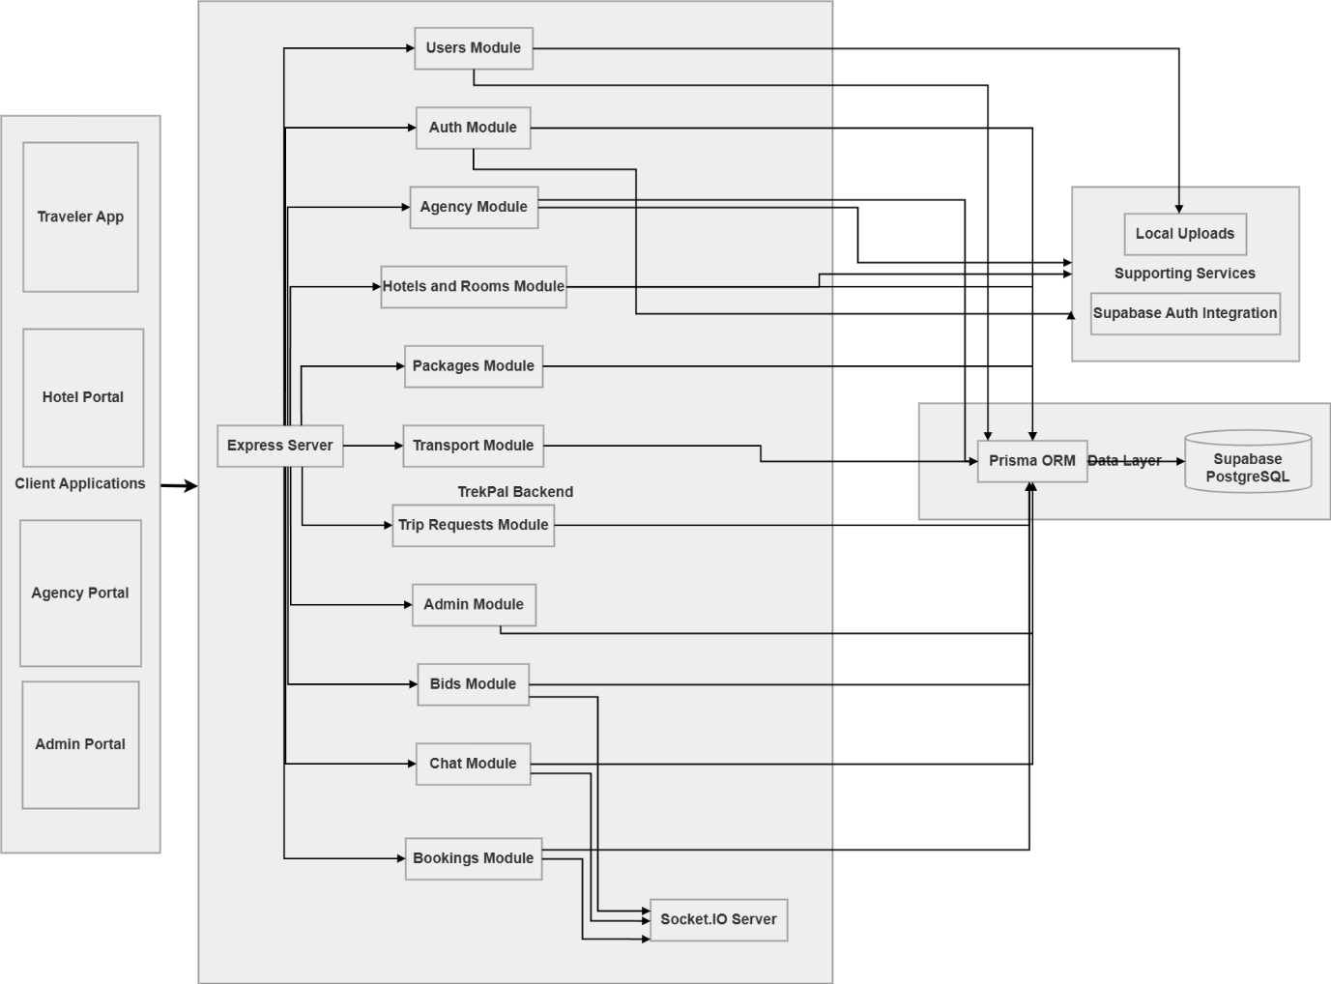
Fig 4.1 Archtecture Diagram

Process Flow Representation

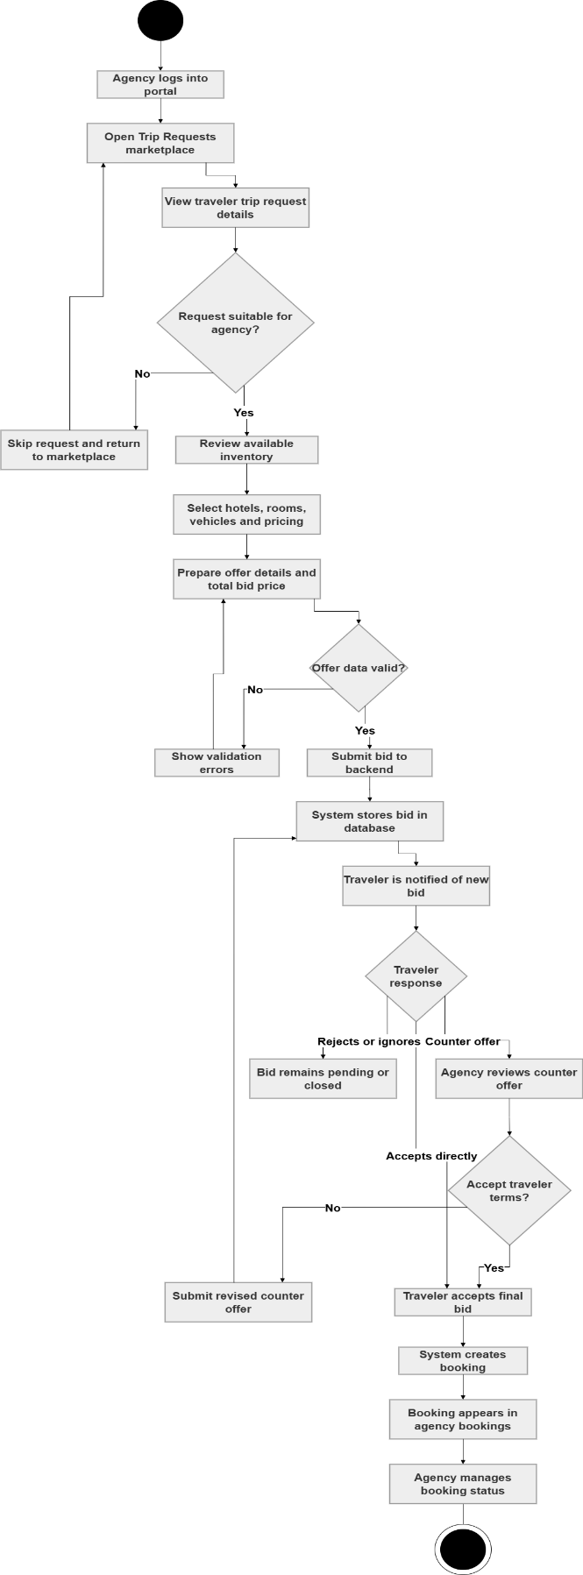
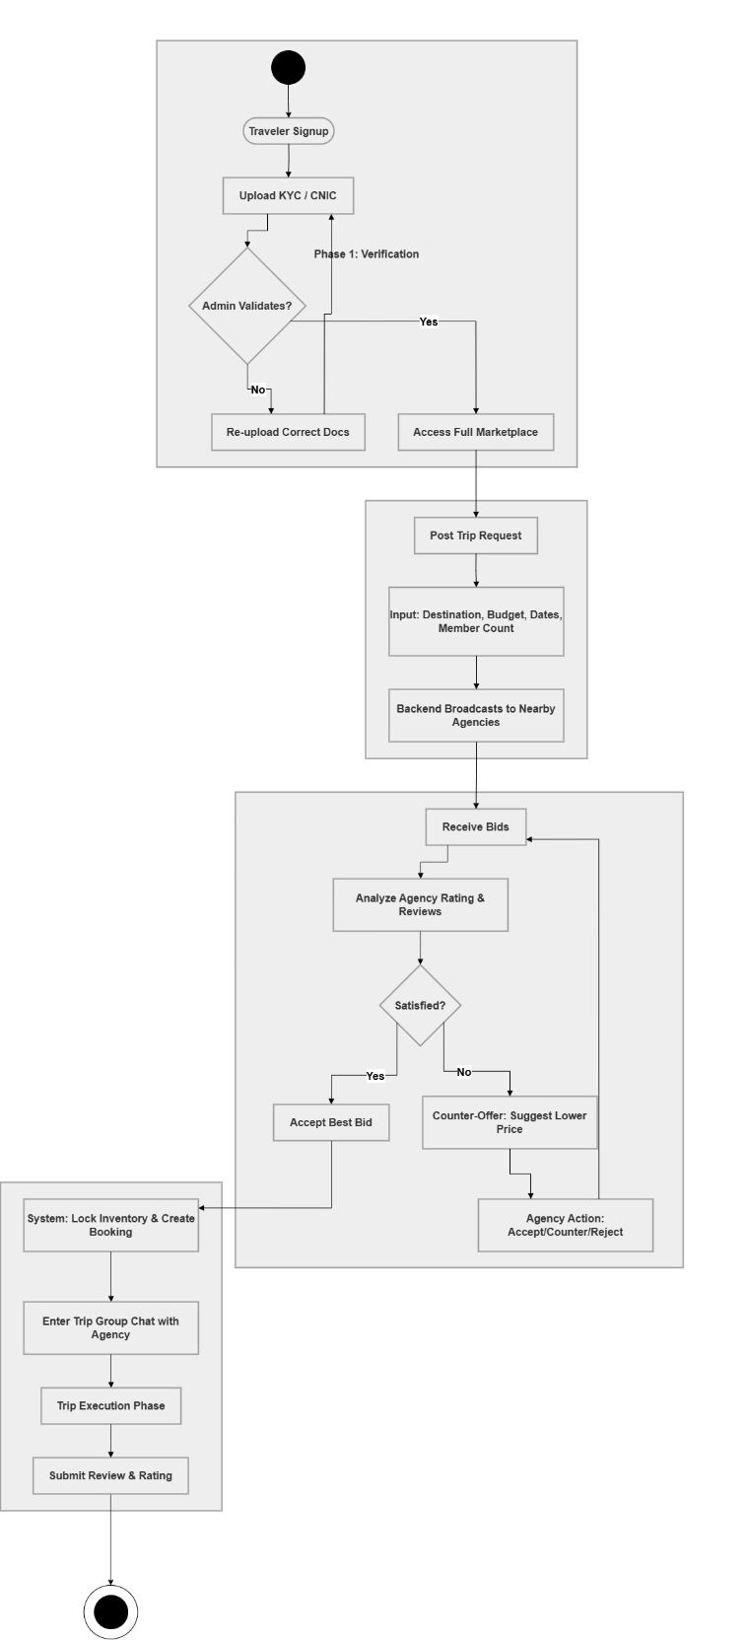
Fig 4.2 Process Flow (Traveller)
Fig 4.3 Process Flow Agency

Design Models
The following section describes the various design models used in the Trekpal System, providing visual representations and explanations of how different components of the system interact and function together to achieve the desired user experience. These models serve as a blueprint for the app's architecture, data flow, and user interactions.

Class Diagram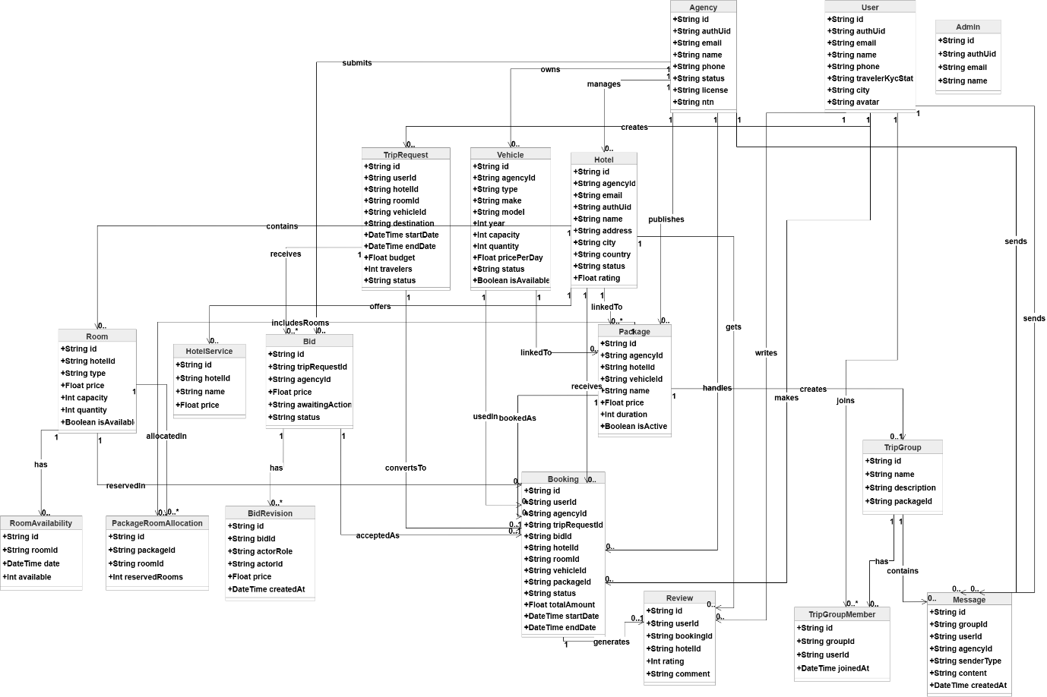
Fig 4.4 Class Diagram

Sequence Diagram
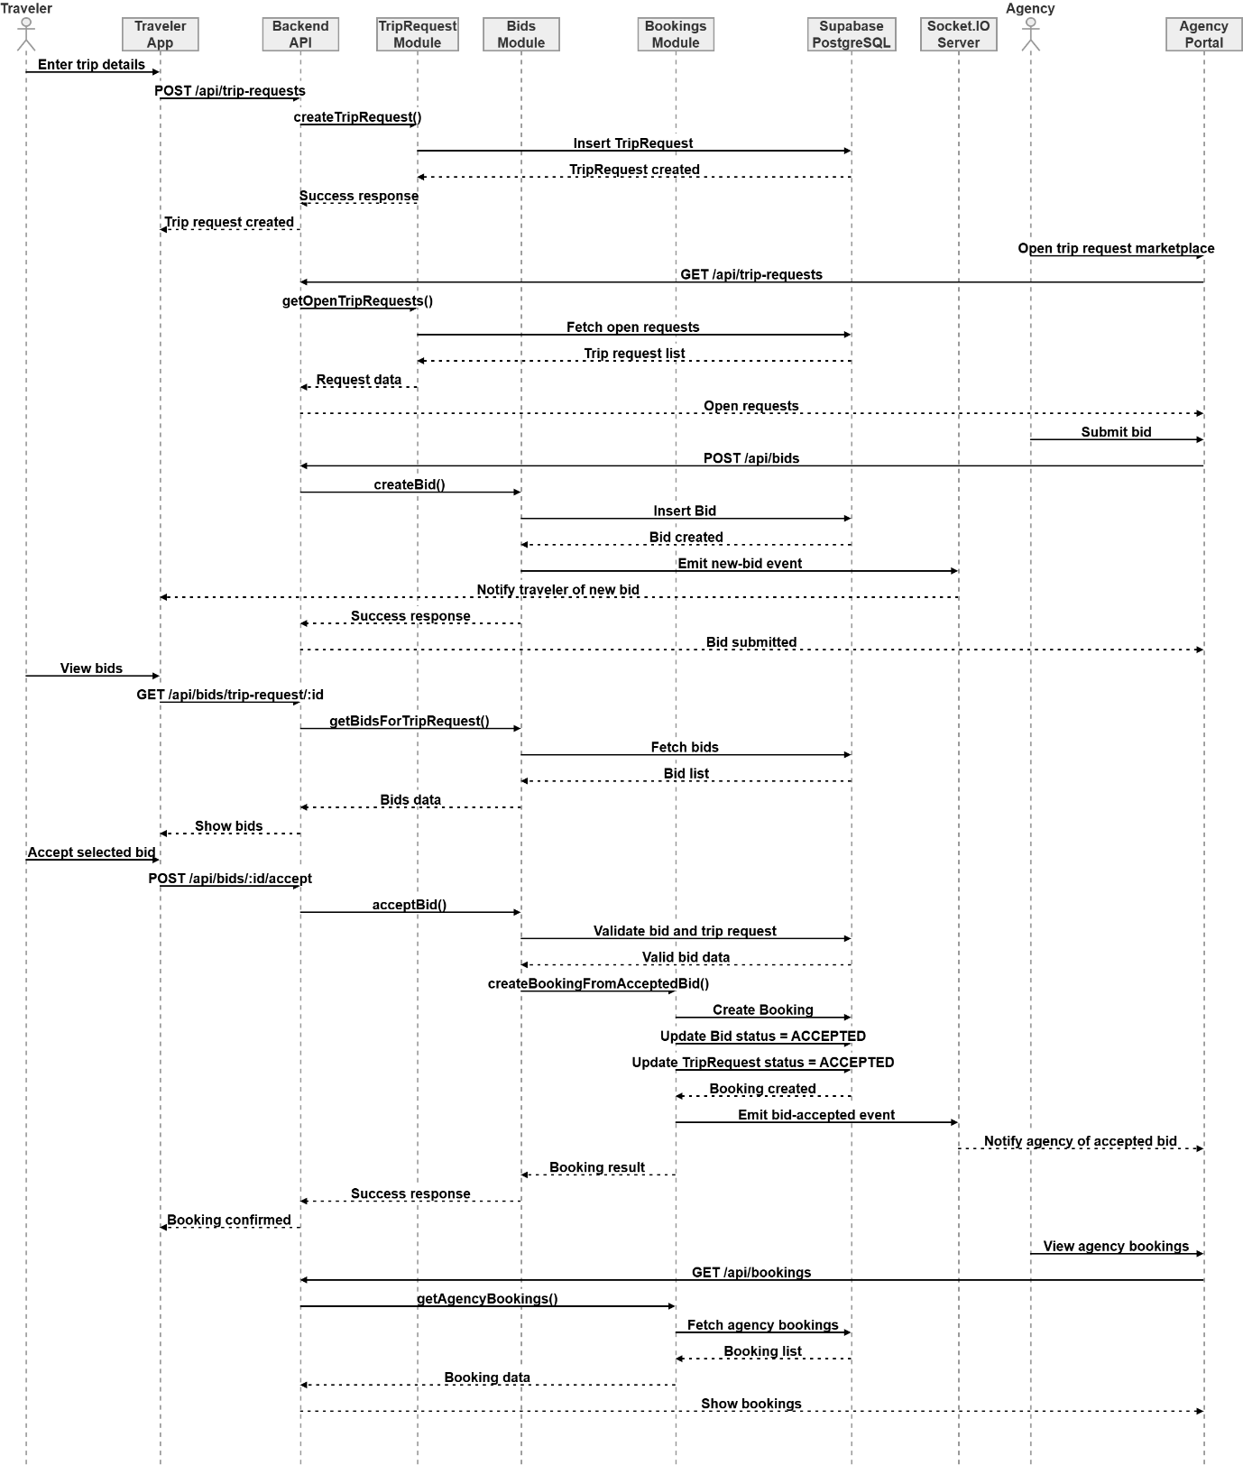
Fig 4.5 Sequence Diagram

State Transition
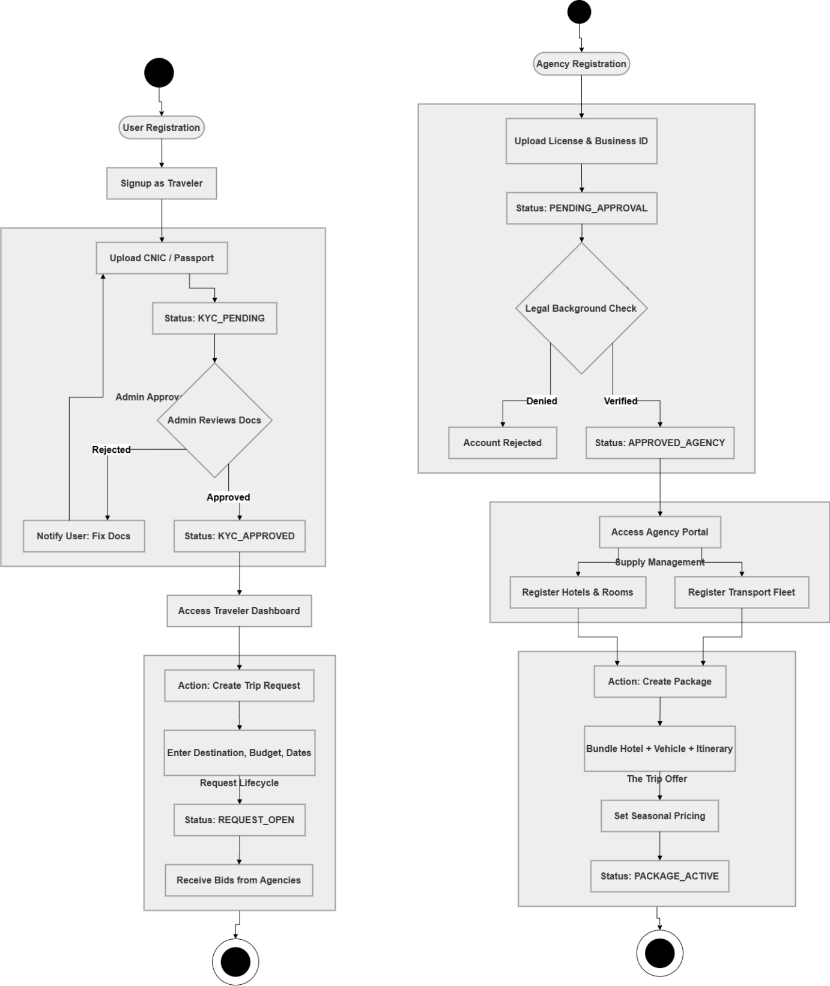
Fig 4.6 State Transition

ERD

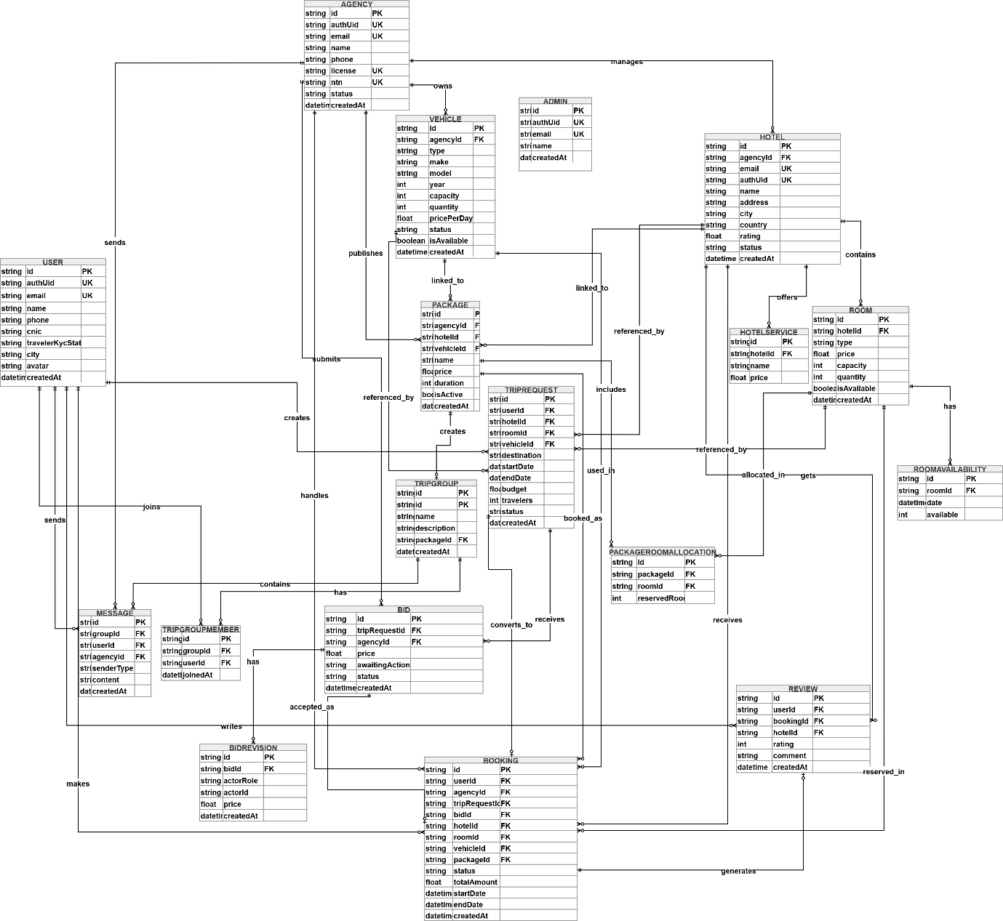
Fig 4.7 ERD

